**Software Requirements Specification**

For

**Online Sales Portal**

Version 1.0 approved

Prepared by:

**SHIVANG AGRAWAL**

**K.HRUSHIKESH REDDY**

**I.SAI HARI KRISHNA**

**ASEEM ANAND**

Group: 14

**TEAM: CODE MANIFEST**

25th March, 2023

# Table of Contents

Table of Contents 2

1. Introduction 3

1.1 Purpose 3

1.2 Document Conventions 3

1.3 Intended Audience and Reading Suggestions 4

1.4 Product Scope 4

1.5 References 4

2. Overall Description 4

2.1 Product Perspective 4

2.2 Product Functions 5

2.3 User Classes and Characteristics 5

2.4 Operating Environment 6

2.5 Design and Implementation Constraints 6

Constraints and other eventualities must be taken into account when designing good software. We will list the factors that must be taken into account when developing this project in this part. 6

• Must be programmed effectively enough to function on the server hardware that is given. 6

• The database will be developed and maintained in a way that makes it of manageable size. 6

• Client side programming and/or web pages must be able to execute effectively on low end hardware. 6

2.6 User Documentation 6

3. External Interface Requirements 7

3.1 User Interfaces 7

3.2 Hardware Interfaces 8

3.3 Software Interfaces 9

3.4 Communications Interfaces 9

4. System Features 9

4.1 Account Registration 9

4.2 Sign in 10

4.3 Search 10

4.4 Add to the list of ongoing transactions 10

4.5 Delete from the list of ongoing transactions 10

4.6 Purchase 10

4.7 Add-Item 10

4.8 Update Account Information 11

4.9 View Account Purchase History 11

4.10 Account Logout 11

4.11 Manage Buyers/Sellers 11

4.12 Help Negotiations 12

5. Other Non-functional Requirements............................................................................................................................................................................12

* 1. Performance Requirements.....................................................................................................................................................................................12
  2. Safety Requirements................................................................................................................................................................................................12
  3. Security Requirements ............................................................................................................................................................................................12
  4. Software Quality Attributes.....................................................................................................................................................................................13

5.5 Business Rules..........................................................................................................................................................................................................13

1. **Other Requirements...............................................................................................................................................................13**

**Appendix A: Glossary....................................................................................................................................................................13**

**Appendix B: Analysis Models ........................................................................................................................................................14**

Revision History

|  |  |  |  |
| --- | --- | --- | --- |
| **Name** | **Date** | **Reason For Changes** | **Version** |
|  |  |  |  |
|  |  |  |  |

# 1. Introduction

# 1.1 Purpose

* The main objective of the On-line Sales Portal (OSP) is to create an on-line portal where people can buy and sell on the same platform.
* It is a one-step store for both the buyer and the seller. The Software Requirements Specification (SRS) document gives us a clear overview of the On-line Sales portal. It explains features and interfaces of the portal.

# 1.2 Document Conventions

The document is written in Calibri Font of size 11. Main headings (size 18) and subheadings (size 14) are written in bold. Some important points in the document are written in Italics. (Size 11)

In some of the cases mentioned below the customer can be a seller or a buyer based on the situation.

# 1.3 Intended Audience and Reading Suggestions

* This document is intended for *Developers, and Software companies* who intend to develop or work with this portal (so that they are aware of the dependencies of the application and how it works) and for the *Managers, Sellers and Buyers* (so that they know what all features this application is having).
* This SRS contains the structure of the application as well as the required hardware and software dependencies of the application, which must be present for the application to function smoothly. For reading this SRS, the reader must have a basic knowledge of *Object-Oriented Programming, Web Development Frameworks. The* reader must also have some knowledge about *UML diagrams.*
* This project is a prototype for the online sales portal. This has been implemented under the guidance of college professors. This project is useful for the management team as well as the general people who want to buy and sell products online.

# 1.4 Product Scope

* This Software system will be an On-line Sales portal for the Company. This is designed to make an online platform on the web where different persons can buy and sell products to each other.
* OSP should be able to *create an account* for either Manager or Customer (Buyer and/or Seller) based on the user choice and on creation of an account it should be able to *generate a unique ID and Password* for the user.
* OSP should be able to *communicate the generated ID to the user through email.*
* OSP should provide an option for a *user to change password* if requested by the user.
* Manager is responsible for control of the entire buy and sell system.
* OSP should provide options by which the *manager categorizes the available products in the portal* and should be able to *add / remove the categories if required.*
* OSP should provide an option for *seller to upload the information regarding the item* he/she wants to sell.
* Similarly options for the *buyer to search for an item, raise a request to buy, negotiate the selling price with the seller and pay money online.*

# 1.5 References

Although the basic outline of the SRS was provided, another website was referred to while the making of this document

<https://krazytech.com/projects/sample-software-requirements-specificationsrs-report-airline-database>

# 2. Overall Description

# 2.1 Product Perspective

This system is intended to create an online marketplace where various people can sell goods with one another. There is a customer login option that allows different people to login in order to buy or sell their merchandise. Customers who are buying and selling products can haggle over the price of an item and purchase goods. Once the contract is agreed upon by the buyer and seller, there is also the option of online money transfers. Also, there is a manager login option that is only available to certain people. The manager is in charge of overseeing the complete purchase and sell systems. There are various types of goods that can be purchased or sold. Moreover, these categories may be added or removed by the manager. The management has the right to deactivate a customer's account and erase any products they have uploaded to sale online if they are thought to be fraudsters. A database with a list of consumers, buyers, sellers, and items is also part of the system.

# 2.2 Product Functions

* A customer can buy or sell an item over the platform.
* To upload an item, customer has to give basic information about the item and its price. (Refer - Section 3)

● If a buyer is interested in purchasing an item, he can raise a request and his bid price.

* The raised price is acceptable if it’s well within the limit the seller agreed to sell upon.
* The buyer can raise the money any number of times until the bid is accepted.
* Payment mode for the shopping is online.
* Manager have certain powers which is described later (Refer - Section 3)

### 2.2.1 For Users (Basic Account features)

* Sign In / Sign Up
* Reset The Password (after basic verification check)
* Account Details
* Search Browser (To find the items they require)
* Search Filter
* Shopping History, Search History and Transaction History
* Online Payment gateway

### 2.2.2 For Manager (Extra features are added)

* Updating Product Information
* Perform audit of matched buy-sell of items
* Managing categories of products
  + Updating the information regarding Sellers and Buyers
* Monitoring transactions (In case of errors)

# 2.3 User Classes and Characteristics

The user classes who use this product are:

* People who are interested in buying and selling products online .The products can be renewed or new.
* Also, people who want to start their business and start-ups similar to Amazon, Flipkart or eBay may also use this system to a great extent, where they can only sell their products.
* Manager who manages the entire buy and sell systems.

# 2.4 Operating Environment

As an online portal software, its sole hardware platform for operation is an internet connection and a background server. Moreover, a database system should be accessible to keep track of various consumers and products.

# 2.5 Design and Implementation Constraints

# Constraints and other eventualities must be taken into account when designing good software. We will list the factors that must be taken into account when developing this project in this part.

# Must be programmed effectively enough to function on the server hardware that is given.

# The database will be developed and maintained in a way that makes it of manageable size.

# Client side programming and/or web pages must be able to execute effectively on low end hardware.

# 2.6 User Documentation

A brief explanation and a quick read through of the SRS document would be enough to grasp how the online sales portal operates. Also, a user's guide that describes the portal in pictures would be useful for easy access to the portal's functionalities.

**2.7 Assumptions and Dependencies**

The users of this portal are required to be familiar with the fundamentals of both the English language and the laptops or other similar devices from which they access the portal because the entire portal is implemented in English. Any product that has been sold or purchased by a customer cannot be returned.

# 3. External Interface Requirements

# 3.1 User Interfaces

## Activity Flow Diagram for an Unregistered User

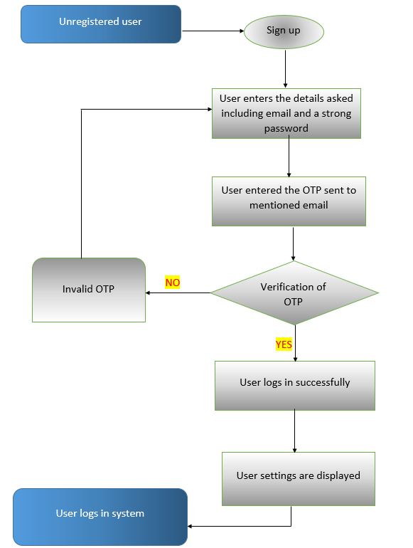

**Note:**  The user can be a manager or a customer.

## Activity Flow Diagram for a Registered User

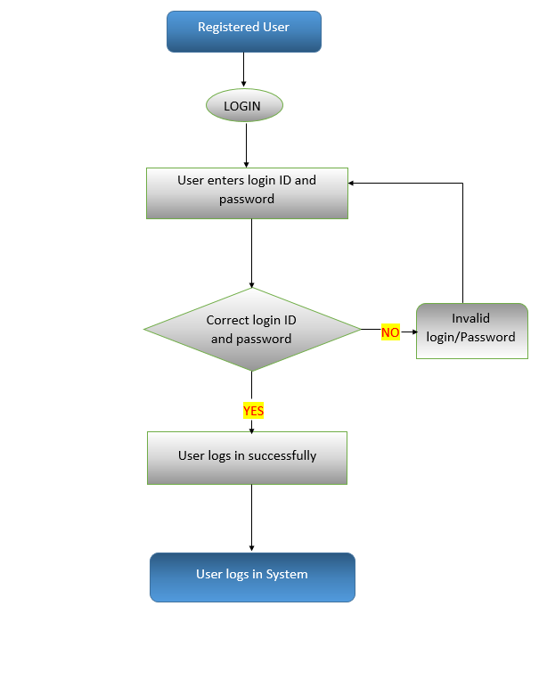

# 3.2 Hardware Interfaces

Any web-based browser can use the software. In addition, hardware is needed on the server side to handle database applications like MySQL, which are needed to keep all the data on product sales and purchases. SQL is used as a middleware software to store all the data entered by the various users on the company's server.

# 3.3 Software Interfaces

* Initially the user can register him/herself either as a Customer or a Manager.
* In order to raise a request to buy something, Login is necessary.
* This user-id and password entered to login will be validated from the database.

If the registration information is accurate, an object will be generated in the database in accordance with that. The lone object of the database class will be created when the software is launched. This one object will be updated whenever the software is closed and will reflect any changes made to the database.

When a customer object is created, the customer can immediately add or delete items from the database; these actions will be performed in database when the customer object is being destroyed.

For various functionalities, such as adding an item, removing an item, setting a price limit for an item, etc., multiple functions will be called.

Similarly, As soon as a Manager Object is created, the Manager can add/remove categories, review an item and remove a customer from the database. In this case functions will be called for functionalities like deleting an account, remove categories, remove product, etc.

# Communications Interfaces

Communications are done through email.

**4.System Features**

**4.1. Account Registration**

**Stimulus**: Click "Sign up" Button

REQ-1. The system shall allow a non-registered user to create a secure account.

REQ-2. The system shall require the following information if the user is manager: Name, Gender, Date-of-Birth, Address including house no, street, locality and city, Telephone number, Email, IM ID, Password.

REQ-3. The system shall require the following information if the user is a customer: Name, city, Contact number, Email, IM ID (optional), Password.

REQ-4. The system will mail a unique id if the details are valid. Passwords can be changed later.

REQ-5. The system will store the information in the database.

## 4.2. Sign in

The users have to log into their account whenever they want to use the sales portal.

REQ-1. The system will ask for a username and password from the user.

REQ-2. If the details provided are accurate and match the ones in the database, and the user will be considered “logged-in”.

**4.3. Search**

The users can search for the item of their choice using search bar and search filters. The system will indicate that there are no items that fit your description and prompt us to check our spelling and try our search again if the phrasing in the search field does not match the description of any item.

## 4.4. Add to the list of ongoing transactions

The system automatically adds a buyer's purchase request to any pending transactions so that the buyer may keep track of it and receive updates.

## 4.5. Delete from the list of ongoing transactions

The buyer can easily remove the item from the list of ongoing transactions if they do not want to see any more updates on it after submitting a request to buy it.

## 4.6. Purchase

The users can purchase items of their choice.

Stimulus: Click "Purchase" Button

REQ-1. The system shall allow a registered and logged-in user to purchase an item.

REQ-2. The system shall display the total cost of the item (including delivery charges).

REQ-3. The system shall allow the user to enter their delivery information.

REQ-4. The user system shall prompt the user to enter their payment information.

REQ-5. On a successful transaction the item (title and price and quantity) will be displayed to the screen.

### 4.7 Add-Item

The sellers can add items on the Sales Portal which are for sale.

**Stimulus:**  Click "Add Item" Button

REQ-1. The system shall allow a registered and logged-in seller to add items they want to sell.

REQ- 2 The user shall be prompted to fill in a form with all details associated with the class ‘Item’: Category of the item, Photo of the item, price limit for selling, Age of the item (if not new), Name of the manufacturing company, city, and basic information about that product.

REQ-3. The system shall allow the user to enter their payment acceptance details.

## 4.8. Update Account Information

The users can update their account information on the sales portal so as to provide their most recent credentials.

Stimulus: Click "Update Account Information" Button

REQ-1. The system shall allow a user to update the information in their account.

REQ-2. The user shall be allowed to view and change their mailing address, billing address, payment information.

REQ-3. The user shall be able to change their password by entering the old one once, and a new one twice.

## 4.9. View Account Purchase History

The user can view the list of items purchased by them in the past. The purchase history shall also depict the date and cost of the past orders.

Stimulus: Click "View Account Purchase History" Button

REQ-1. The system shall allow a registered and logged-in user to view purchases made with their account within the last two years.

REQ-2. The system shall display the date of purchase.

REQ-3. The system shall display the details of each item purchased in a given order.  **4.10. Account Logout**

The user can log out of their account after use.

**Stimulus:**  Click "Logout" Button

REQ-1. The system shall allow the registered and logged-in user to exit his/her account.

### 4.11. Manage buyers/sellers

Manager can see them and can delete their accounts if there’s a probable doubt of fraud.

**Stimulus:**  Click "Manage buyers/sellers" Button

REQ-1. The system shall allow the registered and logged-in manager to delete buyers/sellers.

**4.12. Help negotiations**

Managers can contact both buyer and seller to help solve the gaps or to assist with delivery logistics.

**Stimulus**: Click "Help negotiations" Button

REQ: The system shall allow the registered and logged-in manager to get the email and contact information of both seller and buyer.

1. **Other Non-functional Requirements**

**5.1 Performance Requirements**

In order to maintain an acceptable speed at maximum number of uploads allowed from a particular customer as any number of users can access the system at any time. The server will be working 24X7

## 5.2 Safety Requirements

Any misleading or incorrect details regarding the items added to the portal will lead to a temporary ban of the customer responsible which could be a permanent one (sole discretion of the company).

Once the item is purchased the order cannot be cancelled/modified and a refund cannot be issued.

## 5.3 Security Requirements

Certain rules are made to set the password strong so that it cannot be guessed by the attacker. These rules include ensuring that the password contains a sufficient number of characters and contains not only lowercase letters but also capitals, numbers, and in some cases, symbols.

Users will need to follow the security requirements as mentioned by the payment application.

## 5.4 Software Quality Attributes

## Any web-based platform can use the system because it is customizable. The software is extremely sturdy in that the manager has the authority to convert it from an online sales portal to a shopping site like Flipkart and SnapDeal by simply eliminating all the merchants and selling only branded goods. The portal is adaptable since the manager can add and remove item categories from it.

## 5.5 Business Rules

The manager of the system can manage buyers and sellers of the system. If he finds somebody corrupt, that is, if someone is selling fake items (items that don’t even exist), or someone is involved in a fake money transaction, the manager has the power to remove such customers from the system and block them temporarily or permanently.

**6. Other Requirements**

Licensing requirements: Applicable

Legal, Copyright and Other notices: All rights reserved by our organization.

**Appendix A: Glossary**

## SRS

A software requirements specification (SRS) is a comprehensive analysis of the intended use and setting for the software that is currently being developed. The SRS clearly outlines the functions and performance standards for the software.

**Server**

A server is a computer or computer program which manages access to a centralized resource or service in a network.

## UML

## In the field of software engineering, the Unified Modelling Language (UML) is a general-purpose, developmental modelling language that aims to offer a standardised approach for visualising system architecture.

## API

API is an acronym for Advanced Programming Interface. It is a set of functions and procedures allowing the creation of applications that access the features or data of an operating system, application, or other service.

## HTTP

HTTP means Hypertext Transfer Protocol. HTTP is the underlying protocol used by the World Wide Web and this protocol defines how messages are formatted and transmitted, and what actions Web servers and browsers should take in response to various commands.

**Appendix B: Analysis Models**

## Data Flow Diagrams

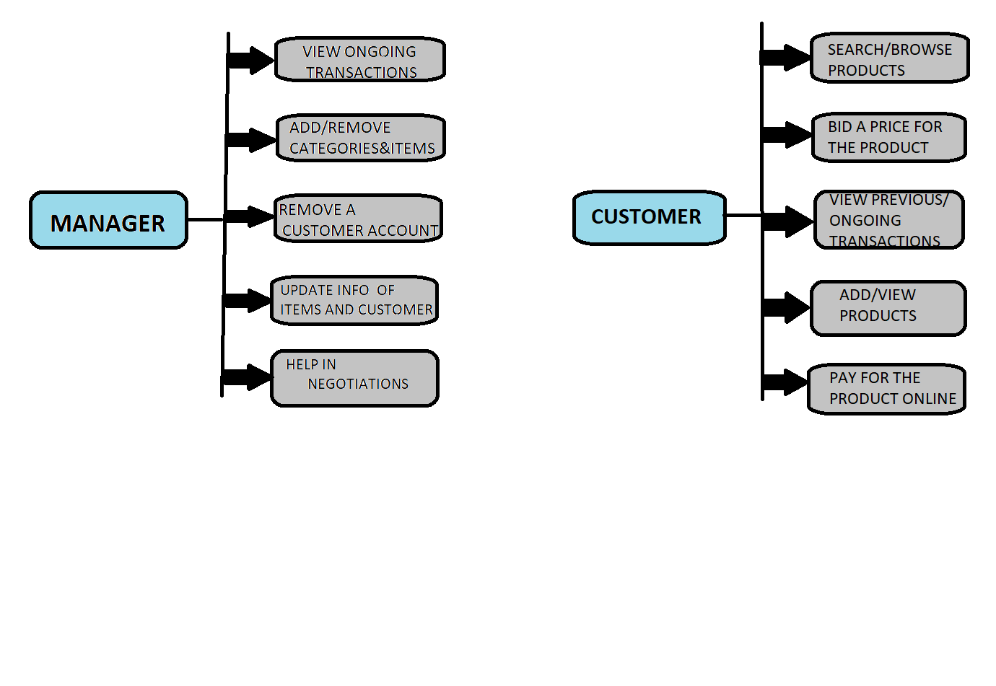

## UseCase Diagrams

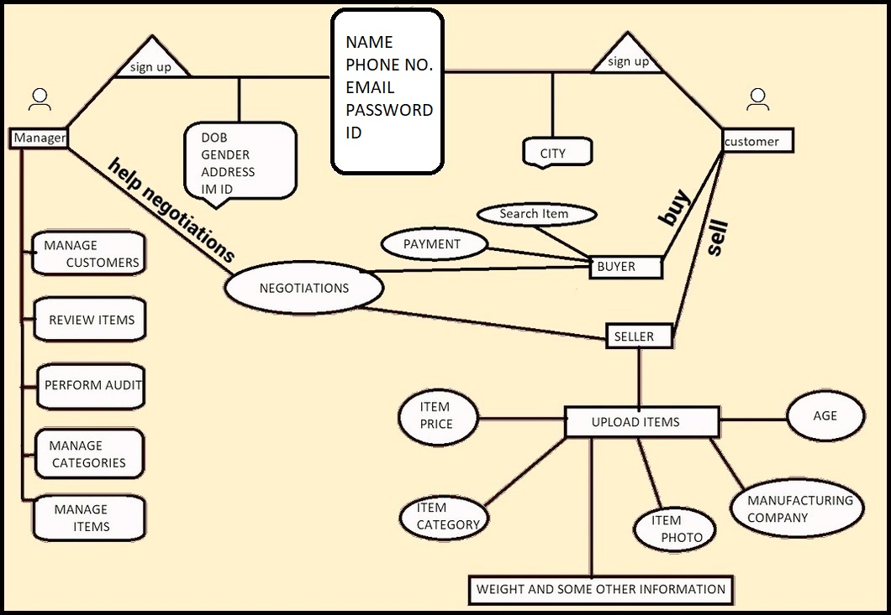

SYSTEM BOUNDARY

**User Class Diagram**